Press Release
Purchase District Health Department
December 2nd, 2020
Purchase District Health Department Confirms Additional cases of Coronavirus (COVID-19)
The Purchase District Health Department has received notification of the cases listed below:
COUNTY | AGE | SEX
Ballard | 20 | F
Ballard | 23 | F
Ballard | 26 | M
Ballard | 6 | F
Ballard | 29 | M
Ballard | 44 | M
Ballard | 24 | F
Ballard | 36 | M
Carlisle | 75 | M
Carlisle | 40 | F
Fulton | 60 | F
Hickman | 29 | M
Hickman | 59 | F
Hickman | 81 | F
Hickman | 83 | M
Hickman | 68 | F
Hickman | 77 | F
Hickman | 59 | M
Hickman | 73 | F
Hickman | 65 | F
Hickman | 59 | F
Hickman | 61 | M
Hickman | 90 | M
Hickman | 73 | M
McCracken | 34 | F
McCracken | 20 | F
McCracken | 35 | M
McCracken | 55 | M
McCracken | 13 | M
McCracken | 33 | M
McCracken | 48 | F
McCracken | 27 | F
McCracken | 74 | F
McCracken | 38 | F
McCracken | 61 | F
McCracken | 59 | F
McCracken | 38 | M
McCracken | 66 | M
McCracken | 42 | M
McCracken | 23 | M
McCracken | 40 | F
McCracken | 57 | M
McCracken | 53 | F
McCracken | 40 | M
McCracken | 78 | F
McCracken | 58 | F
McCracken | 39 | M
McCracken | 28 | F
McCracken | 21 | F
McCracken | 28 | F
McCracken | 35 | F
McCracken | 33 | F
McCracken | 39 | F
McCracken | 25 | F
McCracken | 57 | F
McCracken | 48 | M
McCracken | 43 | F
McCracken | 7 | F
McCracken | 32 | M
McCracken | 87 | M
McCracken | 46 | M
McCracken | 93 | F
McCracken | 92 | F
McCracken | 32 | M
McCracken | 72 | M
McCracken | 56 | F
McCracken | 14 | M
McCracken | 50 | F
McCracken | 60 | F
McCracken | 15 | M
McCracken | 32 | M
McCracken | 51 | F
McCracken | 54 | M
McCracken | 62 | F
McCracken | 61 | M
McCracken | 59 | M
McCracken | 69 | M
McCracken | 56 | F
McCracken | 22 | M
McCracken | 76 | M
McCracken | 83 | F
McCracken | 48 | F
McCracken | 49 | M
McCracken | 3 | F
McCracken | 56 | F
McCracken | 57 | M
McCracken | 62 | F
McCracken | 52 | F
McCracken | 72 | F
McCracken | 29 | M
McCracken | 39 | M

Additional details about these individuals cannot be provided because of medical privacy laws.
The Purchase District Health Department understands that accurate and up to date COVID-19 data is critical. Both individuals and organizations utilize this data to make the most informed decisions to keep people safer through this pandemic. Data that the Purchase District Health Department publishes in the press release is provisional data that hasn’t yet gone through rigorous investigation and is subject to change. Due to this, not every aspect of the data will be precise, and the Purchase District Health Department doesn’t expect it to be. Therefore, corrections are written on the press release in order to provide comprehensive and transparent data. The Purchase District Health Department wants the data as accurate as possible. The Purchase District Health Department is constantly working with positive cases, contact tracers, EMS, labs, and testing facilities to ensure that the public receives the most recent data available, even if that includes changes.
The Purchase District Health Department offers these tips:
• Wash your hands often with soap and water, especially after going to the bathroom; before eating; and after blowing your nose, coughing, or sneezing.
• Avoid close contact with people who are sick.
• Avoid touching your eyes, nose and mouth.
• Stay home when you are sick.
• Cover your cough or sneeze with a tissue, then throw the tissue in the trash.
• Clean and disinfect frequently touched objects and surfaces using a regular household cleaning spray or wipe.
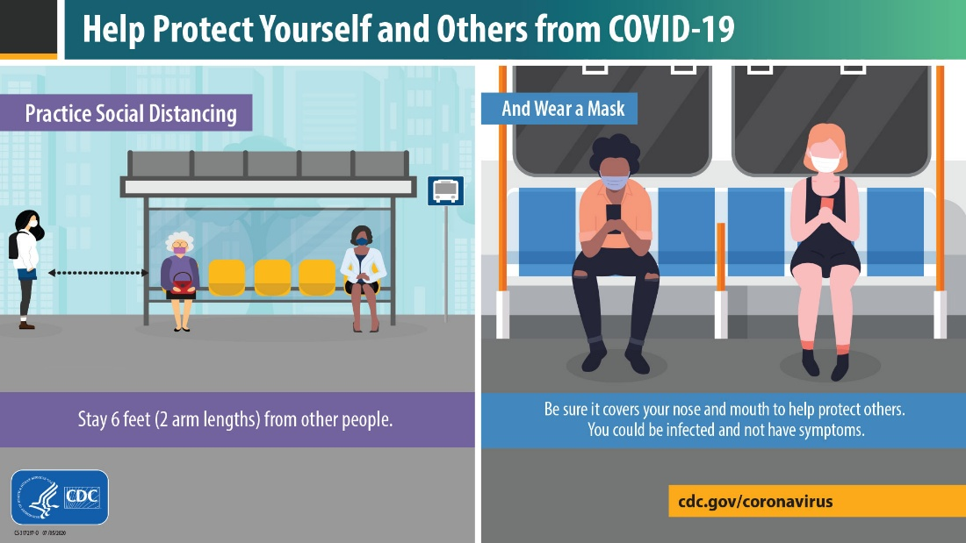
The Purchase District Health Department is working with best interests of our community with reference to statewide guidance and in consultation with KDPH to promote an efficient, standardized, sustainable system supporting all Kentuckians. By rapidly identifying and isolating new COVID-19 cases, the PDHD maintains a high-yield public health intervention to mitigate unrestrained spread of disease. All new COVID-19 cases will be provided written and/or verbal education related to exposure criteria and they will be asked to notify all family, friends, coworkers, and any others who may meet exposure criteria to self-quarantine for 14 days.
This virus can be spread by respiratory droplets. Symptoms of COVID-19 may include fever, cough, loss of taste, or shortness of breath. Individuals who are experiencing symptoms should first contact their primary care medical provider.
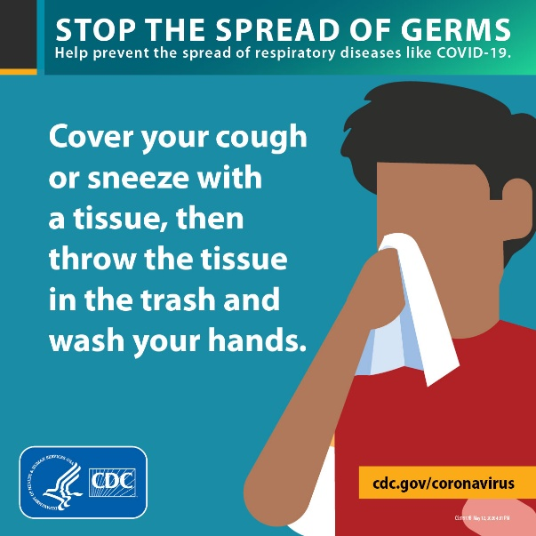
If you are worried or concerned, but otherwise healthy, please see kycovid19.ky.gov for additional information or call the Ky Covid-19 hotline at 1-800-722-5725. Call your medical provider if you develop signs or symptoms of COVID-19. Call the Purchase District Health Department at 270-444-9631 or visit our website www.purchasehealth.org for more information.

Upcoming ECT COVID Testing Schedule
Please visit www.purchasehealth.org for registration.
Thursday, December 3, 2020
9:30-1:00 Fulton County Health Clinic
402 Troy Avenue, Hickman, KY

Friday, December 4, 2020
9:00-12:00 McCracken County Health Department
916 Kentucky Avenue, Paducah, KY

Monday-Tuesday, December 7-8, 2020
9:30-1:00 Ballard County Health Clinic
198 Bluegrass Dr., LaCenter, KY

Wednesday-Thursday, December 9-10, 2020
9:30-1:00 Bardwell Baptist Church
323 Highway 51 North, Bardwell, KY

Friday, December 11, 2020
9:00-12:00 McCracken County Health Department
916 Kentucky Avenue, Paducah, KY

Monday-Friday, December 14-18, 2020
9:00-12:00 McCracken County Health Department
916 Kentucky Avenue, Paducah, KY

